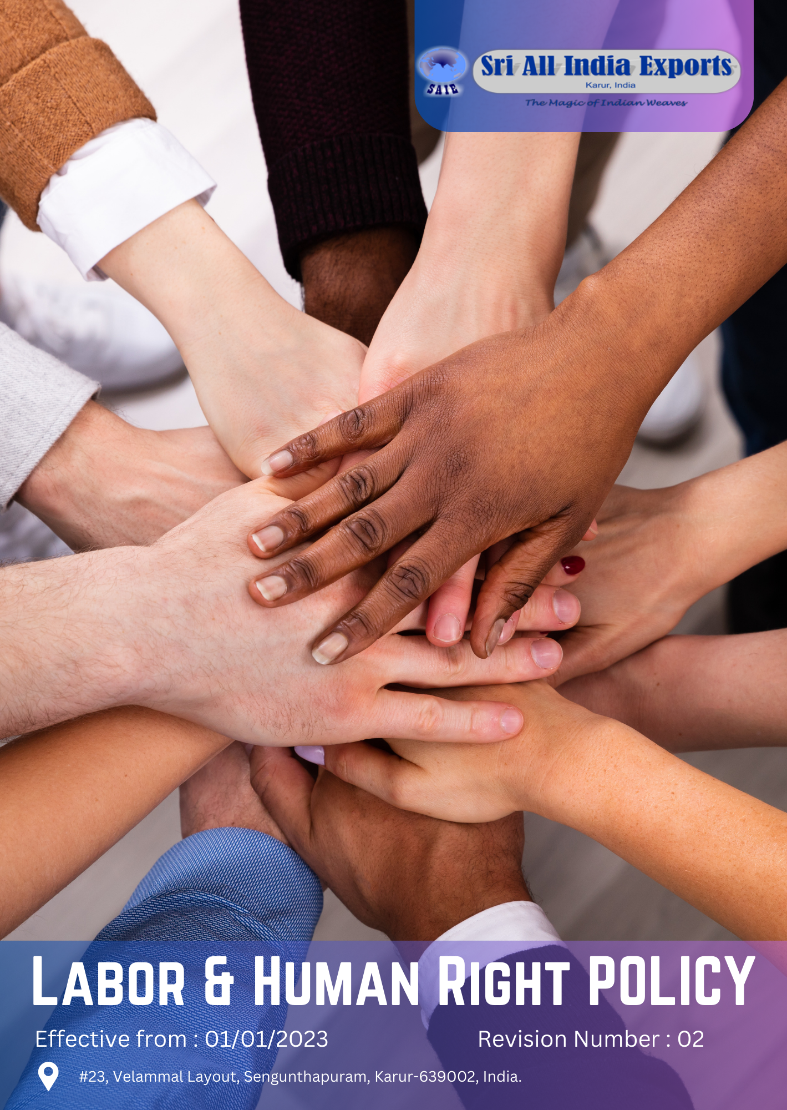

Policy Number

04313

Prepared by

Maria G. White

mariawhite@workerwrite.com
TABLE OF CONTENTS
⧫ INTRODUCTION 1
⧫ SCOPE 2
⧫ POLICY STATEMENT 3
⧫ KEY FOCUS AREA 3
⧫ QUALITATIVE TARGETS 5
⧫ QUANTITATIVE TARGET 7
⧫ CONTINUES IMPROVEMENT 9
⧫ ROLES AND RESPONSIBILITIES: 9
⧫ REPORTING 9
⧫ REVIEW MECHANISM 11
⧫ REVISIONS AND HISTORY 11
⧫ EMPLOYEE ACKNOWLEDGEMENT FORM 12

- INTRODUCTION
Sri All India Exports is dedicated to upholding the highest standards of labor practices, ensuring the well-being, safety, and development of our workforce. As an established leader in the textile industry for over 41 years, we are committed to creating a work environment that fosters fairness, respect, and opportunity. Our labor policy underscores our pledge to protect human rights, promote diversity and inclusion, and ensure ethical labor practices across our operations.

We recognize that our employees are our most valuable asset. By implementing robust policies and initiatives, we aim to provide a safe, equitable, and supportive workplace. This policy serves as a framework to guide our efforts in promoting employee health and safety, improving working conditions, managing labor relations, fostering career growth, preventing child and forced labor, and ensuring diversity, equity, and inclusion within our organization and among our stakeholders.

- SCOPE
This policy is exclusively applicable to the operations of Sri All India Exports, covering all employees, workers, subcontractors, and other stakeholders directly affiliated with our site.

Sr. No. | Name of Site | Address
1 | Sri All India Exports | 23, Velammal Layout, Sengunthapuram, Karur-639002, India.

- POLICY STATEMENT
At Sri All India Exports, we are committed to maintaining an ethical and inclusive work environment where every individual is treated with respect and dignity. We strive to ensure the highest standards of employee health and safety, fair working conditions, and career development opportunities. By fostering positive labor relations and advocating for human rights, we aim to create a workplace that reflects our core values and ethical principles.
- KEY FOCUS AREA
Employees Health and Safety
- Workplace Safety: Develop and implement comprehensive safety protocols to minimize workplace hazards. Regularly update safety procedures based on new regulations and best practices.
- Health Programs: Offer a range of health programs, including regular medical check-ups, vaccinations, mental health support, and wellness initiatives.
- Emergency Preparedness: Create and maintain emergency response plans, conduct periodic drills, and ensure all employees are trained in emergency procedures.
Working Conditions
- Fair Wages: Ensure all employees receive wages that meet or exceed industry standards and living wage benchmarks.
- Work Hours: Adhere to legal limits on working hours and promote work-life balance by implementing flexible working arrangements where feasible.
- Facility Conditions: Maintain clean, safe, and ergonomically designed workplaces, providing adequate facilities such as rest areas and sanitation.
Labor Relations
- Communication: Establish and maintain effective communication channels between management and employees to address concerns and gather feedback.
- Grievance Mechanism: Implement a clear, confidential, and accessible grievance redressal system for employees to report issues or complaints.
- Collective Bargaining: Respect employees' rights to form unions and engage in collective bargaining, providing support for the process.
Career Management
- Training and Development: Offer continuous training and professional development opportunities to help employees advance their skills and careers.
- Performance Management: Implement fair and transparent performance evaluation systems to recognize and reward employee achievements.
- Career Pathways: Create clear career progression pathways and development plans to help employees achieve their career goals.
Child and Forced Labor
- Strict Prohibition: Enforce a zero-tolerance policy for child labor and forced labor, ensuring compliance throughout the organization and supply chain.
- Supplier Audits: Regularly audit suppliers to ensure they adhere to our labor standards and take corrective actions if necessary.
- Remediation Programs: Develop and implement programs to address and rectify instances of child or forced labor if identified.
Diversity, Equity & Inclusion
- Inclusive Culture: Promote a culture of diversity and inclusion through training, policies, and practices that ensure all employees feel valued and respected.
- Equal Opportunities: Ensure equal employment opportunities for all individuals regardless of race, gender, age, religion, or disability.
- Anti-Discrimination: Implement and enforce anti-discrimination policies, providing training on unconscious bias and inclusivity.
External Stakeholder Human Rights
- Supplier Code of Conduct: Develop a code of conduct for suppliers that aligns with our labor policy and human rights standards.
- Supplier Training: Provide training to suppliers on the code of conduct and monitor compliance through regular audits and assessments
- Stakeholder Engagement: Engage with external stakeholders, including local communities and human rights organizations, to promote and uphold labor rights.
- Advocacy: Advocate for ethical labor practices and human rights within the industry and through partnerships with relevant organizations.
- QUALITATIVE TARGETS
Employees Health and Safety
- Introduce a comprehensive safety training program for all new employees, including hands-on workshops and e-learning modules. For example, employees will participate in a safety workshop covering emergency response and hazard identification within their first month of employment.
- Develop a wellness program that includes mental health support and physical health resources. For instance, the program will offer regular mental health webinars and access to on-site health screenings.
- Create and communicate emergency preparedness plans to all employees. Conduct bi-annual emergency drills to ensure readiness, such as fire drills and first aid training sessions.
Working Conditions
- Regularly review and adjust wage structures to ensure alignment with industry standards. For example, conduct annual wage reviews to confirm that salaries meet or exceed the local living wage requirements.
- Implement flexible working arrangements to support work-life balance, such as telecommuting options or flexible hours, tailored to accommodate employees' personal needs.
- Enhance workplace conditions by improving ergonomics and maintaining clean facilities. Examples include upgrading office furniture to ergonomic standards and ensuring that restrooms and break areas are well-maintained.
Labor Relations
- Establish regular meetings between management and employee representatives to address concerns. For instance, hold monthly forums where employees can voice their opinions and management can provide updates on company policies.
- Develop a clear and confidential grievance mechanism for employees to report issues. Create an anonymous reporting system accessible through an online portal or a dedicated hotline.
- Support the formation of worker committees and facilitate collective bargaining processes. For example, provide training for committee members on negotiation skills and labor laws.

Career Management
- Offer a variety of training programs to support employee development. For example, provide access to workshops on leadership skills, technical training, and career advancement strategies.
- Implement a fair performance evaluation system that includes regular feedback sessions. Employees will receive annual performance reviews that focus on their achievements and areas for improvement.
- Develop clear career progression pathways for employees. For instance, create detailed career maps that outline potential advancement opportunities and required skills for different roles.
Child and Forced Labor
- Enforce a zero-tolerance policy for child and forced labor throughout the supply chain. Regularly audit suppliers to ensure adherence to these standards and address any violations promptly.
- Conduct audits of high-risk suppliers to verify compliance with labor standards. For example, perform annual site visits and reviews of supplier labor practices and records.
- Develop a remediation plan to address any instances of child or forced labor found during audits. This plan will include steps for immediate corrective actions and support for affected individuals.
Diversity, Equity & Inclusion
- Inclusive Culture: Promote an inclusive workplace culture through training and policy updates. For instance, implement mandatory diversity and inclusion training for all employees and update company policies to reflect inclusive practices.
- Equal Opportunities: Ensure all employees have equal opportunities for advancement and development. For example, conduct regular reviews of hiring and promotion practices to eliminate biases.
- Anti-Discrimination Policies: Enforce anti-discrimination policies and provide training on unconscious bias. Create a protocol for addressing discrimination complaints and ensure swift action to resolve any issues.

External Stakeholder Human Rights
- Supplier Code of Conduct: Develop and enforce a code of conduct for suppliers that aligns with labor and human rights standards. Ensure all suppliers receive and acknowledge the code of conduct, and integrate it into procurement processes.
- Stakeholder Engagement: Engage with external stakeholders, such as human rights organizations and local communities, to address labor practices and human rights issues. For instance, participate in community meetings and collaborate on human rights initiatives.
- Industry Advocacy: Actively participate in industry forums and advocacy groups to promote ethical labor practices. Contribute to discussions on labor standards and support initiatives that advance human rights in the industry.
- QUANTITATIVE TARGET
Employees Health and Safety
- Achieve a reduction in workplace safety incidents by 40% by 2030 from the baseline year 2022.
- Ensure that 95% of employees complete safety training programs within their first three months of employment by 2030 from the baseline year 2022.
- Increase participation in health screenings and wellness programs to 80% of employees by 2030 from the baseline year 2022.
Working Conditions
- Align 100% of employee wages with local living wage standards by 2030 from the baseline year 2022.
- Upgrade 90% of workstations to ergonomic standards and improve facility conditions to achieve a satisfaction rate of 85% among employees by 2030 from the baseline year 2022.
- Provide flexible work arrangements to 50% of eligible employees by 2030 from the baseline year 2022.
Labor Relations
- Increase participation in employee feedback forums to 75% of staff by 2030 from the baseline year 2022.
- Reduce the average time taken to resolve grievances to 15 days by 2030 from the baseline year 2022.
- Ensure that 100% of labor agreements are reviewed and updated in collaboration with worker committees by 2030 from the baseline year 2022.
Career Management
- Provide a minimum of 20 hours of professional development training per employee annually by 2030 from the baseline year 2022.
- Increase internal promotions by 30% by 2030 from the baseline year 2022.
- Implement structured career pathway programs for 80% of employees by 2030 from the baseline year 2022.
Child and Forced Labor
- Conduct audits of 100% of high-risk suppliers for child and forced labor compliance by 2030 from the baseline year 2022.
- Resolve 100% of child and forced labor findings identified during audits within six months by 2030 from the baseline year 2022.
- Achieve a 100% compliance rate with the child and forced labor policy among suppliers by 2030 from the baseline year 2022.
Diversity, Equity & Inclusion
- Ensure that 100% of employees complete diversity and inclusion training by 2030 from the baseline year 2022.
- Increase the hiring of underrepresented groups by 25% by 2030 from the baseline year 2022.
- Reduce the number of anti-discrimination complaints by 50% by 2030 from the baseline year 2022.
External Stakeholder Human Rights
- Ensure 100% of suppliers acknowledge and adhere to the code of conduct by 2030 from the baseline year 2022.
- Engage in at least 10 stakeholder meetings or forums annually by 2030 from the baseline year 2022.
- Participate in and contribute to 5 industry advocacy initiatives annually by 2030 from the baseline year 2022.
- CONTINUES IMPROVEMENT
- Sri All India Exports is committed to continuously improving our labor practices. Through regular assessments and evaluations, we aim to identify areas for enhancement and implement strategies to promote a fair and supportive work environment. By fostering a culture of continuous learning and development, we strive to achieve excellence in our labor practices and ensure the well-being of our workforce.
- ROLES AND RESPONSIBILITIES:
- Human Resources (HR) Department: Ensures implementation of this policy, monitors compliance with applicable labor laws and regulations, and maintains proper employee records.
- Labor Task Force / HR Committee: A cross-functional team responsible for monitoring day-to-day implementation of fair labor practices, grievance handling, and workplace standards.
- Board of Directors: Provides oversight to ensure the Labor Policy aligns with the company’s strategic objectives, ethical commitments, and legal requirements.
- Employees: Participate in regular training on labor rights and responsibilities, follow workplace standards, and are encouraged to raise concerns or suggestions for improving labor practices.

- REPORTING
At Sri All India Exports, transparent and thorough reporting on our labor practices is essential to maintaining accountability and trust with our stakeholders. Our reporting mechanism ensures that key information is accurately and timely communicated to all relevant parties:

- Labor Performance Metrics:
- Conduct monthly evaluations of key labor performance indicators, including workplace safety incidents, employee satisfaction levels, and compliance with labor laws.
- Utilize advanced data collection methods, such as employee surveys and safety reporting systems, to ensure accurate and real-time data.

- Annual Labor Report:
- Publish a detailed annual labor report that provides an overview of our labor practices, achievements, challenges, and future goals.
- Include case studies and success stories, such as improvements in working conditions or advancements in employee career development.
- Have the report independently audited to ensure accuracy and credibility.

- Employee Feedback Reports:
- Document and report on employee feedback received through surveys and forums, including the number of participants, key themes, and actions taken in response.
- Share feedback trends and improvement actions with employees to maintain transparency and engagement.

- Supplier Labor Practices:
- Conduct and report on annual audits of supplier labor practices, including compliance with our labor policies and any corrective actions taken.
- Include information on supplier adherence to our ethical standards and any areas identified for improvement.

- Stakeholder Engagement Reports:
- Provide reports on stakeholder engagement activities, including meetings, consultations, and feedback received.
- Summarize the outcomes of these engagements and how they have influenced our labor practices and policies.

- Incident Reporting:
- Establish a system for reporting and addressing any labor-related incidents or concerns.
- Provide monthly summaries of incidents, including root cause analysis, corrective actions taken, and any improvements implemented.

- REVIEW MECHANISM
The Human Resources Office is responsible for the implementation, oversight, and review of this policy. This policy will be reviewed every year, and any updates will be communicated as necessary.
- REVISIONS AND HISTORY
Revision. No | Review Date | Changes Made
00 | 01-Jan-2023 | Initial release of the document
01 | 01-Jan-2024 | Initial review of the document
02 | 01-Jan-2025 | Added Roles and responsibilities section; included revision history table


(L.Shanthi)
(S.P.Selvam)
Prepared By: Human Resources Office Approved By: General Manager
Next Review Date: 01/01/2026
- EMPLOYEE ACKNOWLEDGEMENT FORM
I, hereby acknowledge that I have received, read, and understood the Labor & Human Right Policy of Sri All India Exports. I understand the importance of this policy and my responsibility to adhere to and uphold the labor standards and practices outlined within it.

By signing this form, I commit to:
- Complying with all Labor policies and procedures.
- Actively participating in the Labor initiatives and programs implemented by Sri All India Exports.
- Contributing to the continuous improvement of our labor practices.
- Reporting issues, concerns, or violations related to labor practices to the Human Resources Office.
I understand that failure to adhere to the Labor & Human Right policy may result in disciplinary action, up to and including termination of employment.
- Employee Confirmation:
Employee Signature: ___(.C.Rajarajan)
Date: _25.08.25
- Supervisor Confirmation
I confirm that the above employee has received, read, and understood the Labor & Human Right Policy of Sri All India Exports.

Supervisor Signature: __(M.Mahesh)

Date: 25.08.25

